**DIGITAL MARKETTING**

Assignment 4 -Creating a email newsletter and posting it in blog

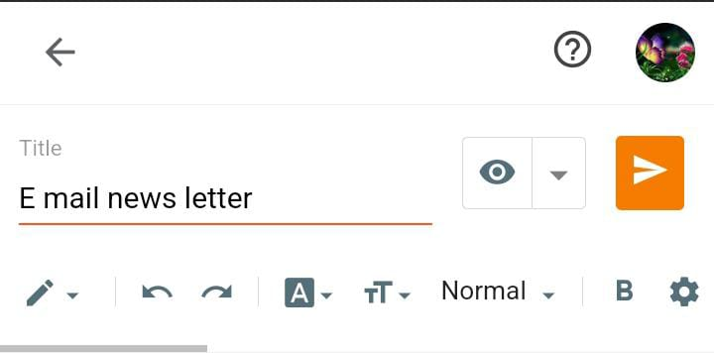

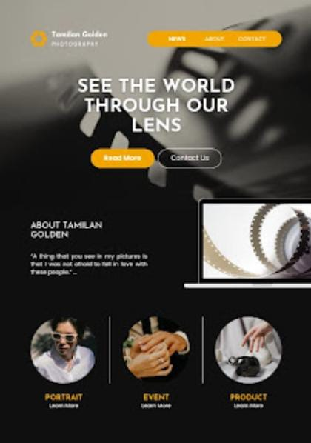

**Fig: Post on blog**

**Email newsletter:**

<https://pleasureofworldisnature.blogspot.com/2023/10/e-mail-news-letter_25.html>

**Email newsletter:**

